PCC Application 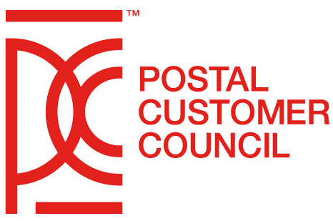

PCCs must complete this application form and send it to the National PCC Team via email to PCC@usps.gov. Check the appropriate box and complete those sections pertaining to the action. A completed copy of this form also must be sent to the local Postal Service District Manager.

□ New PCC □ PCC Name Change □ Postal/Industry Co-Chair Change
□ Administrator Change □ Inactive PCC □ Merge □ Dissolved PCC
_________________________________________________________________________________
CHARTER

Name of PCC:
Inception Date:
Name of District Manager:
__________________________________________________________________________
KEY CONTACTS

PCC Postal Co-Chair:
Address:
Phone #:
Email Address:

PCC Industry Co-Chair:
Title:
Company Name:
Address:
Phone #:
Email Address:

PCC Postal Administrator:
Title:
Address:
Phone #:
Email Address:
__________________________________________________________________________
GENERAL MEMBERSHIP

Initial Number of Executive Board Members:
Initial Number of General Members:
__________________________________________________________________________
FORM COMPLETED BY:

Name:
Title:
Phone #:
Email Address:
__________________________________________________________________________
SEND COMPLETED FORM TO:

Send electronic copy to:
- Assigned USPS HQ PCC Liaison
- PCC@usps.gov
- District Manager

